COMPETENCY-BASED APPROACH IN THE DESIGN OF ENGLISH LEARNING COURSE FOR SHIP ENGINEERS
Yu. Yu. Bevzenko*, A. V. Rosliakova*, M. M. Masonkova**, A. Yu. Yurzhenko**
*Maritime Professional College of Kherson State Maritime Academy, **Kherson State Maritime Academy

КОМПЕТЕНТНІСНИЙ ПІДХІД У РОЗРОБЦІ КУРСУ АНГЛІЙСЬКОЇ МОВИ ДЛЯ СУДНОМЕХАНІКІВ
Ю. Ю. Бевзенко*, А. В. Рослякова*, М. М. Масьонкова**, А. Ю. Юрженко**
*Морський фаховий коледж Херсонської державної морської академії, **Херсонська державна морська академія

КОМПЕТЕНТНОСТНЫЙ ПОДХОД В РАЗРАБОТКЕ КУРСА АНГЛИЙСКОГО ЯЗЫКА ДЛЯ СУДОМЕХАНИКОВ
Ю. Ю. Бевзенко*, А. В. Рослякова*, М. М. Масёнкова**, А. Ю. Юрженко**
*Морской профессиональный колледж Херсонской государственной морской академии, ** Херсонская государственная морская академия

The development of English-language competence of future ship engineers depends primarily on the ability of students to apply knowledge of English in specific communication - on board, to solve professional problems. Nowadays, many new methods of both teaching and learning, with the use of innovative technologies are used in the system of maritime higher education.
Today future ship engineer has to be able to communicate appropriately and speak English fluently. When communicating with crew he is supposed to take into account persuasiveness, culture and style of his language. Because of inefficient communication the problems can arise for example, misunderstandings, failures, emergences. Seafarers, who have faced communication problems, try to improve their communication skills, correct their own mistakes and eliminate drawbacks. For this reason not only existing methodologies are used but also new ones are designed.
Competency-based learning is a relatively new approach to learning design which is proving increasingly popular with employers and learners.
Competency-based learning and teaching is a teaching approach which focuses on the outcomes of language learning, emphasises what learners are expected to achieve with the target language. The keys to having a competency-based system include developing a clear set of learning outcomes around which all of the system’s components can be focused, and establishing the conditions and opportunities within the system that enable and encourage all students to achieve those essential outcomes.
Competency-based learning begins by identifying specific competencies or skills, and enables learners to develop mastery of each competency or skill at their own pace, usually working with a mentor. Learners can develop just the competencies or skills they feel they need (for which increasingly they may receive a ‘badge’ or some form of validated recognition), or can combine a whole set of competencies into a full qualification, such as a certificate, diploma or increasingly a full degree.
The value of competency-based learning for developing practical or vocational skills or competencies is more obvious, but increasingly competency-based learning is being used for education requiring more abstract or academic skills development, sometimes combined with other courses or programs.
The European integration direction of Ukraine's development plays an important role in the development of all spheres of life: political, economic, social, as well as educational, which is the most pressing issue for us. Our state has not only declared its intention to join the European community, but also has signed an agreement according to which it participates in integration processes in the field of higher education in European countries, the main purpose of which is Ukraine's accession and active participation in the European educational space. Therefore, there is a need for fundamental changes in the organization of education in Ukraine based on the paradigm of lifelong learning, the need to solve problems in the field of maritime education in particular, which should qualitatively change its content, forms, methods, tools and technologies.
Talking about educational services, provided to future maritime professionals, it is necessary to take into account the specific features of this profession. Students studying maritime educational programs should acquire knowledge and skills that will be relevant and competitive in the maritime professional environment. That is why, first of all, it is necessary to determine the basic competencies that future seafarers should master during training. One of such competencies is English, which is said to be the international maritime language of communication. The development of English-speaking competence of future seafarers depends primarily on the ability of students to apply knowledge of English, as noted earlier, in specific communication – on board, to solve professional problems.
The main competence of maritime professionals is determined by the International Convention on Standards of Training, Certification and Watchkeeping for Seafarers (STCW) and IMO Model Course 3.17, which takes full account of sections A-V / 1-2 of the STCW [1].
As mentioned above, the main competence that a future seafarer should master is to use English orally and in writing in general maritime communication [3]. Nowadays, there are many new methods of both teaching and learning, with the use of innovative technologies that are widely used in the system of maritime higher education. One of the methodological characteristics of today's vocational education is duality. Dual education aims to combine 50 % of theory at educational institution and 50 % of practice, which should guarantee not only theoretical knowledge but also practical skills.
That is why, in order to ensure high-quality education that meets European and world standards, since 2016, Kherson State Maritime Academy (KSMA) uses blended education with appropriate quality assurance, to improve training, its flexibility.
To provide teachers and students with a digital environment, the educational and communicative pedagogical environment on the MOODLE platform is used, which has a number of advantages. The MOODLE system is very easy to use: free access to the digital environment for anyone and at any time, the only requirement is the availability of Internet connection. The teacher and the student always have the opportunity for feedback, which allows not only the timely completion and verification of tasks, but also the analysis and resolution of existing problems or misunderstandings just during the learning process. The system allows to track the performance of tasks by students, which is the basis for the development of subsequent courses in academic disciplines, taking into account the needs and interests of students. Also, the MOODLE platform has the opportunity to place materials for independent work in the electronic course of the teacher and exams in a separate course for all groups of a separate course and department.
The program of the course “Maritime English for professional purpose” provides for conducting practical training sessions, performing independent work and conducting an exam or test for knowledge control [2]. The MOODLE platform has the ability to place materials for independent work in the electronic course of teachers and exams in separate courses for all groups of a separate course and department. For the size of independent work materials, we have developed electronic courses of level A1-A2 called “General English” for first-year cadets, level B1 called “Maritime English” for second-year courses. The structure of each of the above courses includes modules (Fig. 1), which have different tasks, namely: glossaries, game exercises, forums, quests, project work, group work, cases.
At the end of each module, students must complete a quiz that has a passing score (60 % of the total testing) (Fig. 2). Without passing the level of success, the student will not be able to pass the next quiz [4, 5].
Marks while face-to-face classes, namely the oral competence at the end of each module, the teacher edits manually in the electronic gradebook of e-course. All course activities contain a separate column in the gradebook.
In order to increase the level of students' motivation, the author's electronic courses in the educational and communication pedagogical environment of LMS MOODLE contain elements of gamification (the use of game techniques in a non-game environment to solve professional problems). Such elements include the following: badges, progress bar, game-based exercises (crosswords, puzzles, quizzes etc.), quests, course map, missions and levels, points, leaderboards etc.
The game design of e-courses consists of a course map at the beginning, which explains what levels the course has, elements of storytelling. According to the rules of the modular system of education, the e-course “English for Professional Purposes” consists of five modules that follow one another. That is, seeing the map, the student knows where he stopped and how much more to go to master the main goal of the course – to use English orally and in writing in general maritime communication [1].
Elements of gamification transform learning into an informal environment. Gamification in blended learning forces students to study better in the classroom and perform tasks independently outside educational establishment [5].
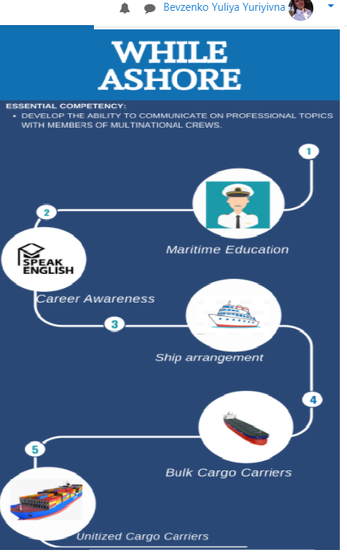
Fig. 1 – Structure of I semester “Maritime English” e-course [3]

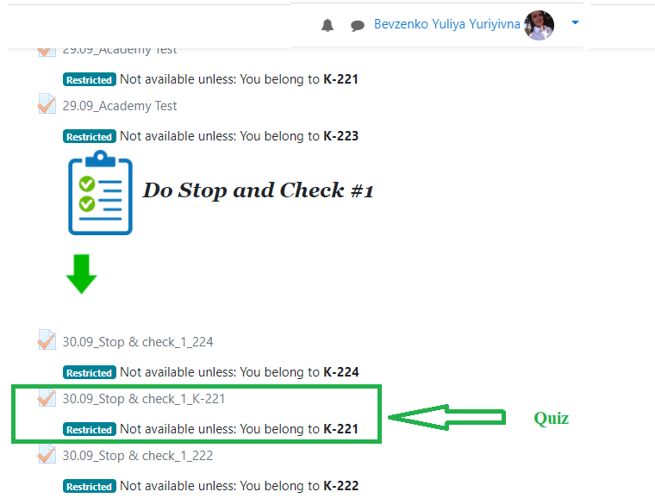
Fig. 2 – Examples of course activities with a testing at the end of the module
Training of ship engineers using blended learning (face-to-face and electronic – MOODLE system: forums, gamified exercises, project and group work, essays, etc.) to obtain theoretical training in maritime educational institution forms the communicative competence of future ship engineer, which is one of the most necessary tasks for future specialists.

References

- IMO. 2011. STCW including 2010 Manila amendments: STCW Convention and STCW Code (3rd consolidated, 2011 edition). London: International Maritime Organization.
- Trager G., Hall E. Culture and Communication: A Model and an Analysis // Explorations and Communication. 2004. № 3. – P. 32–38.
- Bondarenko V., Moroz O., Shetsova I. While ashore: coursebook. Kherson: “STAR” PH, 2018. 132 p.
- Yurzhenko A. Тhe concepts of “communicative competence” and “gamification of English for special purpose learning” in scientific discourse, EUREKA: Social and Humanities, Number 6, 2018. – P. 34–38. DOI: http://dx.doi.org/10.21303/2504-5571.2018.00803
- Popova H., Sherman M., Yurzhenko A. Interactive course “Maritime English” in the professional training of future mariners, Development trends in pedagogical and psychological sciences: the experience of countries of Eastern Europe and prospects of Ukraine: monograph / edited by authors. 2nd ed. Riga, Latvia: “Baltija Publishing”, 2018. – P. 603–621.

Information about authors

Bevzenko Yuliya Yuriivna – Teacher, Maritime Professional College of Kherson State Maritime Academy.
Rosliakova Anna Volodymyrivna – Head of Shipboard Training Department, Maritime Professional College of Kherson State Maritime Academy.
Masonkova Mariia Mykhailivna – Specialist of International Affairs Department, Kherson State Maritime Academy.
Yurzhenko Alona Yuriivna – Ph.D. in Pedagogy, Head of International Affairs Department, Kherson State Maritime Academy.

Відомості про авторів

Бевзенко Юлія Юріївна – викладач, Морський фаховий коледж Херсонської державної морської академії.
Рослякова Анна Володимирівна – завідувач навчально-виробничої практики, Морський фаховий коледж Херсонської державної морської академії.
Масьонкова Марія Михайлівна – спеціаліст відділу з міжнародних зв’язків, Херсонська державна морська академія.
Юрженко Альона Юріївна – к.п.н., начальник відділу з міжнародних зв’язків, Херсонська державна морська академія.
Сведения об авторах

Бевзенко Юлия Юрьевна – преподаватель, Морской профессиональный колледж Херсонской государственной морской академии.
Рослякова Анна Владимировна – заведующий учебно-производственной практикой, Морской колледж Херсонской государственной морской академии.
Масёнкова Мария Михайловна – специалист отдела международных связей, Херсонская государственная морская академия.
Юрженко Алёна Юрьевна – к.п.н., начальник отдела международных связей, Херсонская государственная морская академия.

